**COLLEGE OF DEVELOPMENT EDUCATON**

**2nd Semester School Year 2018-2019**

**Banghay- English 2**

II- Jacinto, School of the future

February 1, 2019

I. Objectives

Differentiate and read correctly the short e and a words(Pan-Pen, Man-Men, Tan-Ten) EN2PWR-IVd-13

II. Subject Matter

“Short e and a words”

References:

Materials: Colored papers, pictures, art papers and markers.

Methodology: 3 I’s

III. Procedure

|  |  |
| --- | --- |
| Teachers activity | Students activity |
| A. Preliminary  1. Checking of assignment  Do we have assignments?  Okay let’s check.  2. Recall  Yesterday what did we do?  What does it all about?  Can you give me an example?  3. Motivation  Today we will have a new lesson which is related to that topic. But before that I will play a song then you will forward this ball to your seatmate. The one whose holding it will be getting a paper and tell what’s in the picture.  (play a song) | Yes Ma’am!  (the pupil will check their works)  Yesterday we discussed the short a words CVC pattern.  It’s all about the short a words.  For example Man.  (they will forward the ball) |
| B. Presentation of the lesson  1. Presentation of the lesson  How was the activity?  What does the picture shows in the activity we do?  Yes because our topic for today was all about “Short e and a words”  2.Lesson Proper  Here are some of the examples of short e and a words.  Let’s read, ready begin.  Those are examples of the short e and a words.  When the word has letter e, it’s called short e words.  When it has the letter a, it is short a words.  Can you please read the sentence?  What’s the short e words in a sentence?  How about the short a word?  Very good!  3.Abstraction  Those words are all example of the short e and a words.  Now why do we need to understand the difference between the short a and e words?  Excellent!  Now that you can differentiate the two short words it will be easier to you to read it correctly. Am I correct? | The activity was fun and interesting.  The picture was e and a short words.  Bat Bet  Sat Set  Jam Jem  Lad Led  Beg Bag  Men Man  Jaysi beg for the bag.  The short e word is Beg.  It’s the bag teacher.  For us to differentiate and read the short e and a words correctly.  Yes Ma’am. |
| C. Application  Now together with your group do this quietly but before that let’s read the direction.  Here’s the criteria for todays activity.  (they will present their works) | Direction: Together with your group read the chart aloud. Give the teacher a piece of paper.   |  |  | | --- | --- | | Criteria | Score | | No. of words read | 5 | | Cooperation | 5 | | total | 10 | |

IV. Evaluation

Direction: Differentiate the two given picture . Name the other picture and write correct answer in the given space.

1. _ pan  _________ 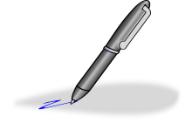

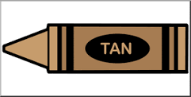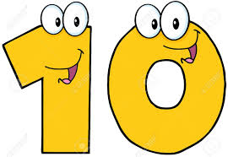

2. _______ tan



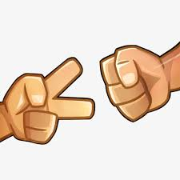3._ Bad ___________

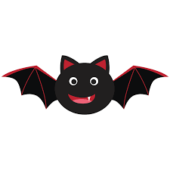

4. _________ bet

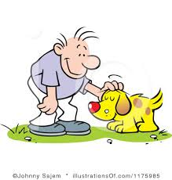

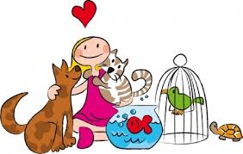

5.___________ pat

V. Assignment

Write short e words that can be partner with the short a words.

1. Lad- _______

2.Man- _______

3. Mat-_______

4. Pat-_______

5. Bat-______

Prepared by:

Joy Lyn N. Adriatico

Will be submitted to:

Rachel G. Vales