A Detailed Lesson Plan in Science VI
March 13, 2019

- OBJECTIVES
At the end of the 50 minute discussion, the pupils are expected to:
- compare inner and outer planets
- demonstrate willingness to learn about the inner and outer planets and;
- describe the characteristics of inner and outer planets.

- SUBJECT MATTER
- Topic: The Inner and Outer Planets
- Reference: https://www.bobthealien.co.uk/solarsystem/innerouter.htm
c. Materials: Pictures, Laptop, LCD projector, Manila Paper
d. 21st Century Skills: Critical Thinking and Collaborative Skills
e. Values Integration: Cooperation
f. Methodology: 3 I’S (Introduction, Interaction, Integration)

- PROCEDURE

Teaching Hints | Teacher’s Activity | Pupil’s Activity
- Preliminary Activities  Greetings  Opening prayer  Securing the Cleanliness  Checking of Attendance  Checking of Assignment | Good morning class!  Student A, kindly lead the prayer  Before you take your seats, arrange it properly and pick up the pieces of paper on the floor.  Class Secretary, kindly check the attendance of your group mates.  Do we have an assignment? | Good morning, teacher!  ( the pupil’s will pray)  ( The pupils will do what the teacher say)  (The leader will check the attendance of his/her classmates)  None, Teacher!
B.  1. Recall  2. Motivation  3. Introduction  4. Interaction  5. Application  6. Generalization | What was the last topic that we discussed?  What about it?  Very Good!  So, what are the eight planets in the solar system?  I have here pictures of the planets all you have to do is identify what planets what I’m going to show you and identify if it is inner or outer planets.  Are you ready, class?  What planet is this?  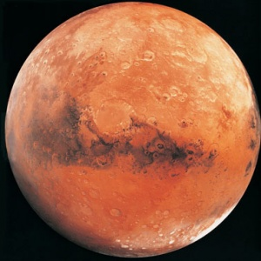  Is this an inner or outer planet?  What planet is this?  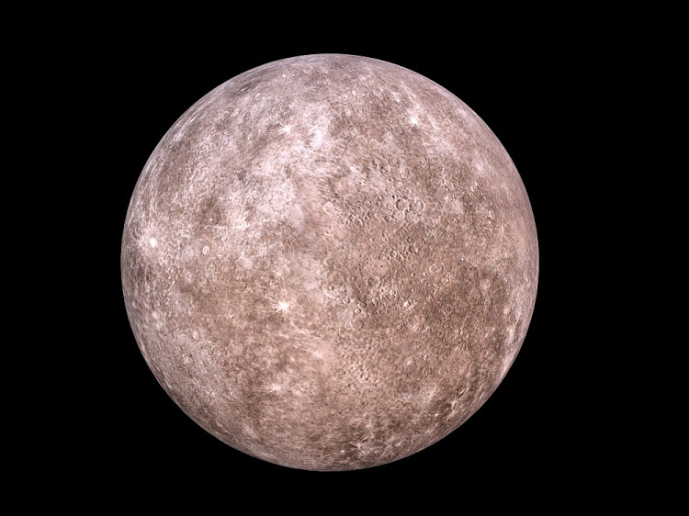  Is this an inner or outer planet?  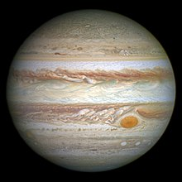  How about this?  Is this an inner or outer planet?  What about this?  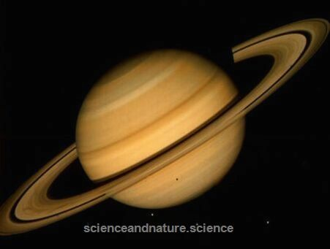  Is this an inner or outer planet?  How about this?  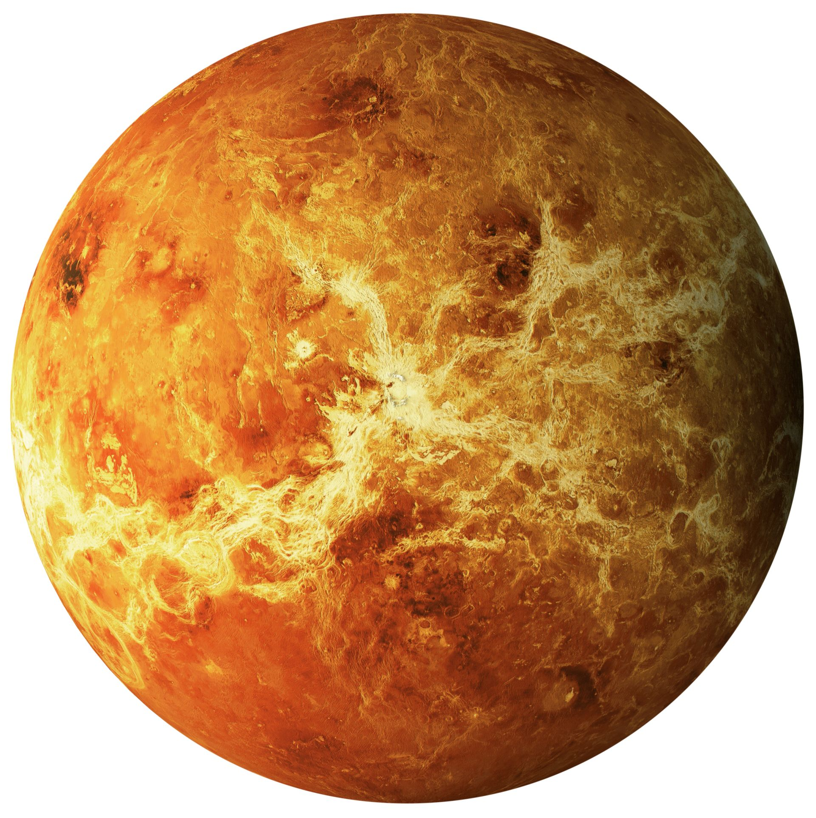  Is this an inner or outer planet?  What about this?  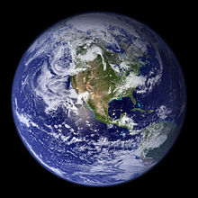  Is this an inner or outer planet?  What planet is this?  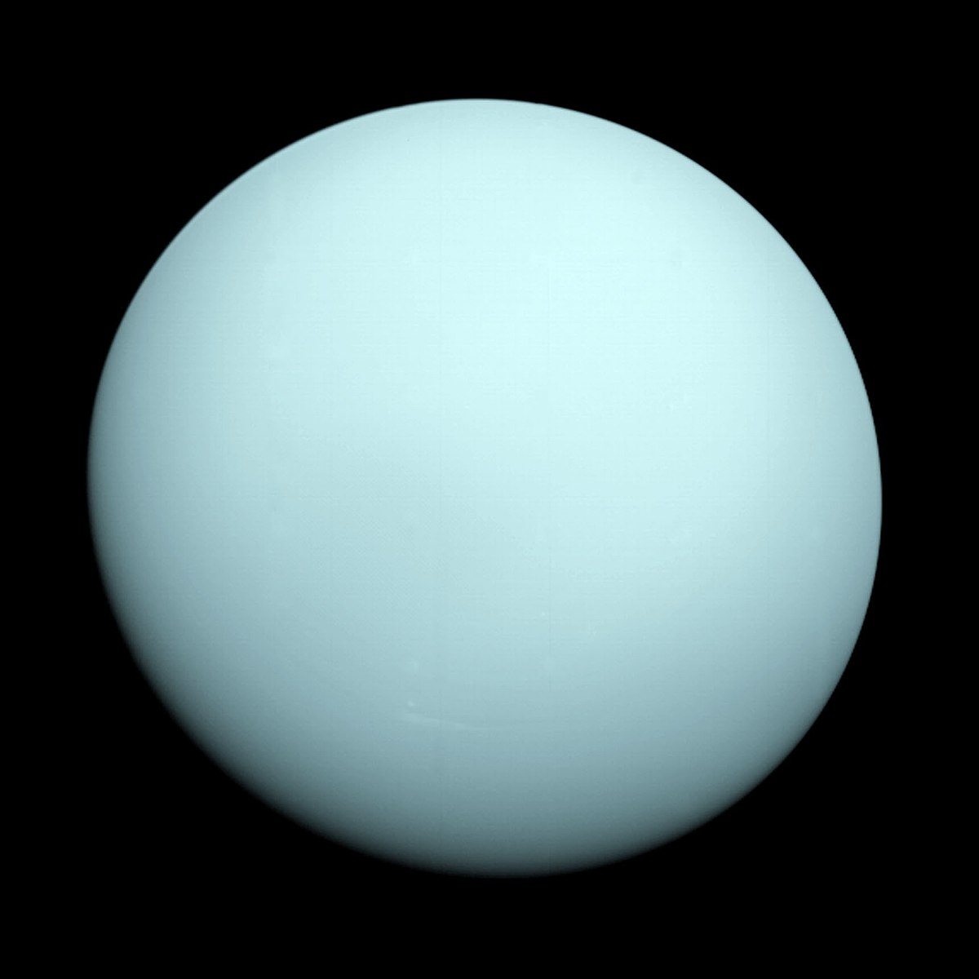  Is this an inner or outer planet?  The last one?  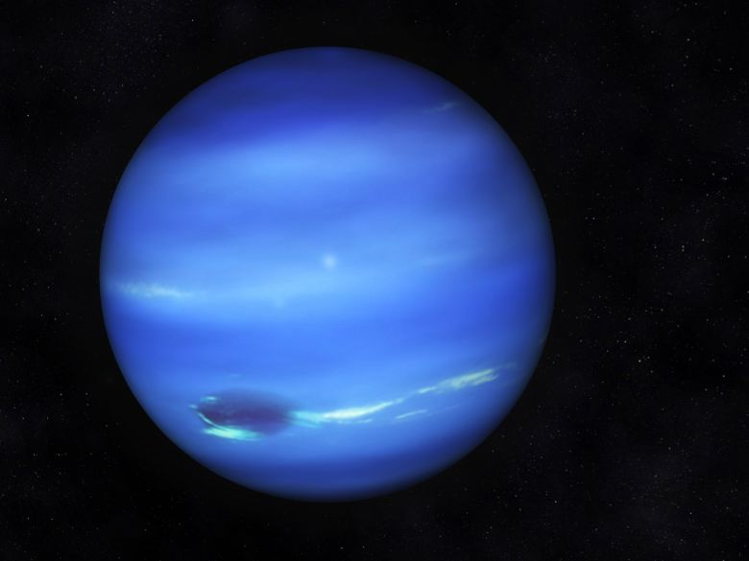  Is this an inner or outer planet?  Okay, later let’s see if you identify it correctly.  So, now, we are going to talk about the inner and outer planets.  Let’s discuss the unique characteristics of the inner and outer planets.  What do we mean by inner planets?  Very Good!  What about outer planets?  Excellent!  Since, we already know the composition of the inner and outer planets.  When it comes to sizes what do you think is the smallest planets?  The biggest?  Earth is the largest of the inner planets, while Jupiter is the largest planet in the outer planets.  What planets has no atmosphere?  Inner planets have solid surfaces and thin surfaces while outer planets is a ball of gas with no atmosphere  In theory, it would be possible to stand on each of the inner planets, although you would only survive on Earth.  Most of the Outer Planets are made of gas. It is likely that they have much smaller solid or liquid center. It would be impossible to stand on any of the outer planets.  What planet has a greater density?  So is earth an inner or outer planet?  Therefore, inner planets has a greater density while outer planets smaller density.  The size and composition of the planets is caused by the density of the elements that makes up the planets. The elements in the Inner planets are more closely packed together, causing them to be smaller and solid.  Despite being larger, the elements that make up the outer planets are less densely packed together causing them to be quite light for their size.  What planet has a thin atmosphere?  So is Venus an inner or outer planet?  The contents of the atmosphere of the inner planets varies from planet to planet.  The outer planets has a similar atmosphere consist of mostly of Hydrogen and Helium with methane. Other gases are present although in much smaller quantities.  When do you think they discover the earth?  The inner planets are known by the ancients for thousand of years ago.  Of the Outer Planets, only Jupiter and Saturn were observed by ancient astronomers.  What is the fastest planet? the slowest?  Compared to the much larger outer planets, the inner planets spins quite slowly but they orbit the sun quickly  All of the outer planets spin quicker than the inner planets but they orbit the sun slowly.  How may moons does a Jupiter have?  Is a Jupiter inner or outer planet?  Inner planets has a few moons. Only earth and Mars have moons orbiting it.  All of the Outer planets have many moons orbiting them.  What is the most beautiful planet?  What makes the Saturn beautiful?  Is Saturn inner or outer planet?  None of the inner planets have rings orbiting them.  All of the outer planets have rings orbiting them.  Why are the Inner and Outer planets so different from each other?  If you were given a chance to travel in space were would it be in outer planets or inner planets and why?  What are the two groups of planets?  What are the inner planets  S  What about the outer planets? | How planets move around the sun  Because of Rotation and revolution that’s why it moves.  Mercury, Venus, Earth, Mars, Jupiter, Saturn, Uranus and Neptune  Yes, we are ready!  Mars  An inner planet  Mercury  An inner planet  Jupiter  An outer planet  Saturn  An outer planet  Venus  An inner planet  Earth  An inner planet  Uranus  An outer planet  Neptune  An outer planet  They are the planets that is composed of water, soil and rocks or they are called the rocky or terrestrial planets.  They are the planets that are the gas giants.  The inner planets.  The outer planets.  Outer planets.  Earth  Inner planet  Venus  Inner planet  Thousands of years ago.  Mercury and jupiter  63 moons  Outer planet  Saturn  Because of its ring.  Outer planets  (Answers may vary)  Inner and Outer planets  Mercury, venus, earth and mars  Jupiter, Saturn, Uranus and Neptune.

Evaluation

Direction: Draw a smiley if the statement is correct and a sad face if it is wrong.
- Mercury, Earth, Venus and Mars are the
outer planets.
- The four planets closest to the Sun are
inner planets.
3. The largest planet is Saturn.
4. The Earth is the third planet from the Sun.
- Venus is the brightest planet in the
Solar System.

Assignment

- Draw the planets revolving the Sun in the Solar System in a long sized bond paper.

Prepared by:
Crecille Joy M. Recario

Submitted to:
Ma’am Chatyline M. Deyto
jhhjahsCooperating Teacher

