A Detailed Lesson Plan in Science VI
March 13, 2019

- OBJECTIVES
At the end of the 50 minute discussion, the pupils are expected to:
- compare inner and outer planets
- use graphic organizer to describe the characteristics of inner and outer planets and;
- demonstrate willingness to cooperate with the group

- SUBJECT MATTER
- Topic: The Inner and Outer Planets
- Reference: https://www.bobthealien.co.uk/solarsystem/innerouter.htm
c. Materials: Pictures, Laptop, LCD projector, Manila Paper
d. 21st Century Skills: Critical Thinking and Collaborative Skills
e. Values Integration: Cooperation
f. Methodology: 3 I’S (Introduction, Interaction, Integration)

- PROCEDURE

Time Frame | Teaching  Hints | Teacher’s  Activity | Pupil’s  Activity | IM’s
(5min) | - Preliminary Activities  Greetings  Opening prayer  Securing the Cleanliness  Checking of Attendance  Checking of Assignment | Good morning class!  Student A, kindly lead the prayer  Before you take your seats, arrange it properly and pick up the pieces of dirt that you may see on the floor.  Class Secretary, kindly check the attendance of your group mates.  Do we have an assignment? | Good morning, teacher!  ( the pupil’s will pray)  ( The pupils will do what the teacher say)  (The leader will check the attendance of his/her classmates)  None, Teacher!
(5min) | B.  1. Recall  2. Motivation  3. Introduction  Presentation of the Objectives  4. Activity  5. Interaction  6. Integration  7. Application  8.Generalization | What was the last topic that we discussed?  What about it?  Very Good!  So, what are the eight planets in the solar system?  I have a few surprises under your chairs.  Whoever gets a question will answer it and find the planet and place it on its own orbit.  I am the Red Planet.  Who am I?  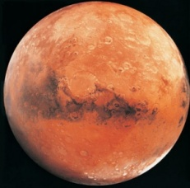  I revolve the fastest, that’s why I am the fastest planet.  Who am I?  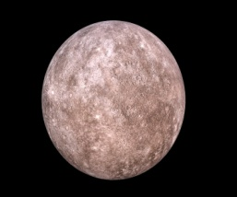  I am the biggest and I have the Great Red Spot.  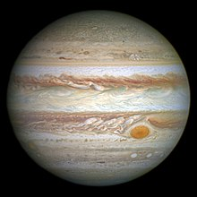  Who am I?  I am the beautiful planet.  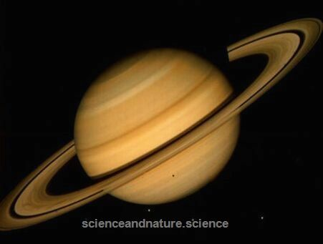  Who am I?  I am the hottest planet.  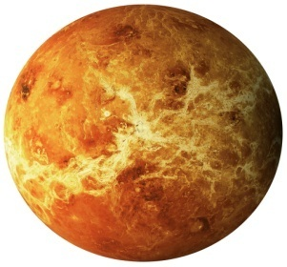  Who am I?  I am the only planet that can sustain life.  Who am I?  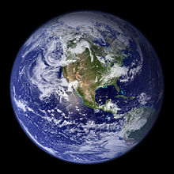  I am tilted on one side, I am the rolling planet.  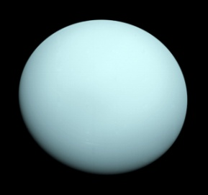  Who am I?  I am the blue ice giant with a Great Dark Spot.  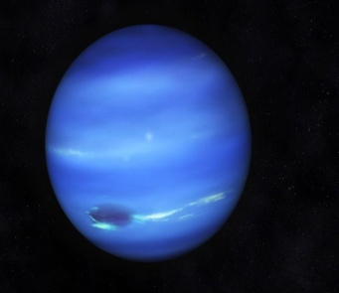  Who am I?  Very Good!  Did you know that these planets are grouped into two?  They are divided by the asteroid belt between Mars and Jupiter.  We have the Inner and Outer planets. We will find out why they were grouped as such.  Here is our Objectives to be attain today.  Please read.  I hope that we will attain this objectives.  But before we proceed to our discussion, let’s have an activity.  You will be divided into three groups.  Since you are already in your group mates you will be guided according to group standards  Please read.  To grade your activity here is our criteria  Please read.  Each group will be given a handout, you will get information in the handout to do your task. You will do the activity in 5 minutes.  Use graphic organizer to organize your answers. Here is your task.  Are you done, class?  Post your output in the board and then report.  So, now, let’s discuss your answers.  What do we mean by inner planets?  Very Good!  What about outer planets?  Excellent!  When it comes to sizes what do you think is the smallest planets?  The biggest?  What planets has no atmosphere?  Inner planets have solid surfaces and thin surfaces while outer planets is a ball of gas with no atmosphere  Most of the Outer Planets are made of gas. It is likely that they have much smaller solid or liquid center. It would be impossible to stand on any of the outer planets.  What planet has a greater density?  Therefore, inner planets has a greater density while outer planets smaller density.  The size and composition of the planets is caused by the density of the elements that makes up the planets. The elements in the Inner planets are more closely packed together, causing them to be smaller and solid.  Despite being larger, the elements that make up the outer planets are less densely packed together causing them to be quite light for their size.  Compared to the much larger outer planets, the inner planets spins quite slowly but they orbit the sun quickly  All of the outer planets spin quicker than the inner planets but they orbit the sun slowly.  How many moons does a Jupiter have?  Inner planets has a few moons. Only earth and Mars have moons orbiting it.  All of the Outer planets have many moons orbiting them.  None of the inner planets have rings orbiting them.  All of the outer planets have rings orbiting them.  How many planets in all if there are 8 inner planets and 8 outer planets?  What will happen if there are 16 planets in the solar system?  If you were given a chance to travel in space were would it be in outer planets or inner planets and why?  Draw your choice.  What are the two groups of planets?  What are the inner planets?  What about the outer planets?  How do you compare inner planets from outer planets?  Excellent!  Why do we call them inner planets?  Why do we call them outer planets? | How planets move around the sun  Because of Rotation and revolution that’s why it moves.  Mercury, Venus, Earth, Mars, Jupiter, Saturn, Uranus and Neptune  Yes, we are ready!  Mars  Mercury  Jupiter  Saturn  Venus  Earth  Uranus  Neptune  Objectives:  At the end of the 50 minute discussion, the pupils are expected to:  - compare inner and outer planets  - use graphic organizer to describe the characteristics of inner and outer planets and;  - demonstrate willingness to cooperate with the group  (The pupils will count off)  Standards to follow:  - Avoid creating noise  - Make the task quick and;  - If done, clap your hands  - A leader will report in the class.  Criteria:  Correctness-25%  Presentation-20%  Timeliness-20%  Discipline- 20%  Cooperation-15%  Group 1:  Give the names of the inner planets, explain why they are called the terrestrial planets and describe the characteristics of the inner planets.  The Inner Planets  The four planets closest to the Sun—Mercury, Venus, Earth, and Mars---are the inner planets or terrestrial planets. They are similar to Earth. All are solid, dense, and rocky. None of the inner planets has rings. Compared to the outer planets ,the inner planets aare small. They have shorter orbits around the sun and they spin more slowly. Venus sins backward and spins the slowest of all the planets. All of the inner planets were geologically active at one time. They are all made of cooled igneous rocks with inner iron cores. Earth has one big, round moon, while Mars has two very small, irregular moons. Mercury and Venus do not have moons.  Group 2:  Name the outer planets, explain why they are called the gas giants describe the characteristics of the outer planets.  The Outer Planets  Jupiter, Saturn, Uranus, and Neptune are the outer planets of our solar system. These are the four planets farthest from the Sun. The outer planets are much larger than the inner planets. Since they are mostly made of gases, they are also called gas giants. The gas giants are mostly made of hydrogen and helium. These are the same elements that make up most of the Sun. Astronomers think that most of the nebula was hydrogen and helium. All of the outer planets have numerous moons. They also have planetary rings made of dust and other small particles. Only the rings of Saturn can be easily seen from Earth.  Group 3:  Using Venn Diagram, compare and contrast the inner and outer planet.  The Inner and Outer Planets  The four planets closest to the Sun—Mercury, Venus, Earth, and Mars---are the inner planets or terrestrial planets. They are similar to Earth. All are solid, dense, and rocky. None of the inner planets has rings. Compared to the outer planets ,the inner planets aare small. They have shorter orbits around the sun and they spin more slowly. Venus sins backward and spins the slowest of all the planets. All of the inner planets were geologically active at one time. They are all made of cooled igneous rocks with inner iron cores. Earth has one big, round moon, while Mars has two very small, irregular moons. Mercury and Venus do not have moons.  Jupiter, Saturn, Uranus, and Neptune are the outer planets of our solar system. These are the four planets farthest from the Sun. The outer planets are much larger than the inner planets. Since they are mostly made of gases, they are also called gas giants. The gas giants are mostly made of hydrogen and helium. These are the same elements that make up most of the Sun. Astronomers think that most of the nebula was hydrogen and helium. All of the outer planets have numerous moons. They also have planetary rings made of dust and other small particles. Only the rings of Saturn can be easily seen from Earth.  The Inner and Outer planets have many things in common they both orbit around a star. In this case the star they orbit is the Sun. All eight planets are round which make them similar. Besides all of them being planets, all follow an elliptical orbit, all are spherical.  Yes, teacher!  (the students will post and report their output)  They are the planets that is composed of water, soil and rocks or they are called the rocky or terrestrial planets.  They are the planets that are the gas giants.  The inner planets.  The outer planets.  Outer planets.  Earth  Inner planet  Mercury and Jupiter  63 moons  There are 16 planets in all.  Possible Answer:  - Maybe the planets will bump to each other  - We may have another living planets  (Answers may vary)  Inner and Outer planets  Mercury, venus, earth and mars  Jupiter, Saturn, Uranus and Neptune.  We compare inner and outer planets by their unique characteristics and their composition  They orbit around the Sun.  They orbit far from the sun | (Pictures, cartolina)

Evaluation

Direction:
Write BTS if the statement is correct, if the statement is wrong underline the word that makes it incorrect and change it with the correct answer/word.
- Mercury, Earth, Venus and Mars are the outer planets.
- The four planets closest to the Sun are inner planets.
- Outer planets are mostly made up of helium and hydrogen.
- Inner planets have smaller density than outer planets
- The inner planets spin slowly but orbit the Sun quickly while the outer planets spin quickly but orbit the Sun slowly.

6-10. Compare and Contrast the Inner and Outer Planets.

Assignment

Bring Cartolina’s, scissors, paste, string, for the mobile solar system.

Prepared by:

Crecille Joy M. Recario
Student Teacher

Noted by:

Ma’am Chatyline M. Deyto
Cooperating Teacher

