Detailed Lesson Plan in Science III
February 2, 2015
Grade III- Mabini
Glenn O. Flor

- OBJECTIVE
At the end of 50-minute discussion, 75% of the pupils should be able to describe common landforms.

- SUBJECT MATTER

- Topic: Landforms in the Community
- Science Process: describing and observing
- Reference: Science 3 T.G. pages 161- 162
- Materials: Pictures, Manila paper, Metacards, chalk, blackboard
- Values: Appreciation of natural resources and cooperation

- PROCEDURE

Teacher’s Activity | Pupils’ Activity
- Preparatory Activities  - Greetings  - Opening Prayer  - Classroom Management  - Checking of Attendance  - Checking of Assignment  - Review of the Past Lesson  What was the last lesson that you have studied?  Again, can you name those water forms found in the environment?  Very good!  - Motivation  Class, what can you sees in this illustration?  Where does tree normally grow?  Is there any kind of land form in your community?  What are those?  Are there plants growing in these landforms?  Have you tried going to mountain?  How did you feel while climbing?  Are land forms naturally occurring or man- made?  - Development of the Lesson  - Presentation  Class, would you like to go somewhere?  We will have a tour on different landforms in the environment but before that let us first define some unfamiliar terms.  Class, bear in mind those words because  We’ll be encountering those words in our lesson.  - Activity  Now, we will have a group activity. I have here the criteria on how you will be rated.  (Teacher will distribute the activity sheets.)  Please follow the instructions written in the activity sheets I have given you.  (Teacher will grade the pupils output.)  - Analysis and Discussion  Class, I have here pictures of different landforms.  Who among you here knows this landform?  Very good!  Will you describe an island?  Very good!  What about this one?  What is a canyon?  Very good!  What kind of landform this next picture shows? Will you describe it?  Very good!  What does this next picture show?  Will you describe a mountain?  Very good!  This next picture shows?  Who wants to describe a plain?  Very nice!  What about this next picture?  Will you describe it?  Good!  Who among you here is familiar with this next picture? What land form is this?  Very good!  What does this next picture shows?  Will you describe it?  What about this picture?  Who wants to describe a peninsula?  Very good!  This picture shows?  What is a hill?  That’s correct!  - Generalization  Can you name again the different landforms?  Very good!  Valuing:  Are landforms important?  In what way do these landforms important?  - Application  Alright, let’s have another activity. I will play music. As it stops, you must be paused. The one who moves will be the one to do the activity. | We studied about water forms.  Those are hot spring, lake, river sea, bay etc.  A tree!  On land.  Yes teacher!  Those are mountains, plains, and river.  Yes teacher! There are varied plants growing in those land forms.  Yes teacher!  I’ve tried going to mountain. It’s a bit tiring yet I enjoyed seeing beautiful views of nature.  It’s naturally occurring.  Yes teacher!  Unlocking of the Difficult Words  Choose the meaning of words in column A to the words in column B.  A B  - Form a. ground  - Land b. to shape  - Erosive c. pointed end  - Peak d. tend to fall down  - Narrow e. limited  - Surround f. encircle  - Ravine g. deep  (Pupils will answer.)  Criteria  Rikas kan Paggibo – 30%  Kalinigan kan Gibo- 20%  Disiplina - 20%  Pagtatarabangan - 20%  Pag-uulat - 10%  100%  Group 1  List down landforms that can be found in your community.  Group 2  Draw at least one landform and describe it.  Group 3  Give the importance of landforms.  (Pupils will do the activity and report.)  That is an island.  It is a piece of sub continental land surrounded by water.  That is a canyon.  A canyon is a deep ravine between pairs of escarpments or cliffs.  That is a plateau. It is a flat elevated landform that rises sharply above the surrounding area.  It shows a mountain.  A mountain is a large land form that stretches above the surrounding land in a limited area.  That picture shows a plain.  A plain is a flat area and this occur as lowland.  That is a valley.  Valley is a large area between hills.  An isthmus! It is a narrow strip of land connecting two larger land areas, usually water on either side.  A delta.  It is a landform that forms at the mouth of a river.  That shows a peninsula.  A peninsula is a piece of land bordered by water on three sides but connected to mainland.  A hill!  A hill is a landform that extends above the surrounding terrains.  The different landforms are island, canyon, plateau, mountain, plain, valley, isthmus, delta, peninsula and hill.  Yes teacher!  These landforms serve as shelter for different life forms.  Instructions: Match each picture with its name. Connect the yarn.  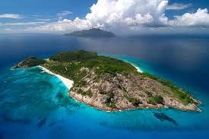 a. plain  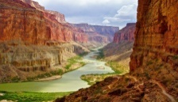 b. mountain  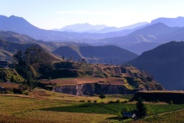 c. hill  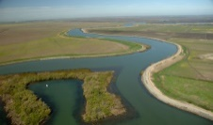 d. peninsula  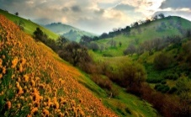 e. delta  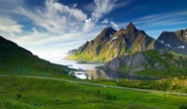 f. plateau  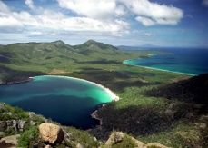 g. isthmus  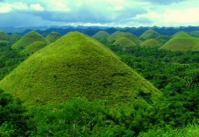 h. island  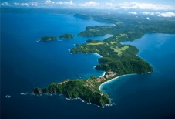 i. valley  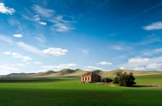 j. canyon

- EVALUATION

Give at least five landforms and describe each. Write your answer on the chart below.
LANDFORMS | Descriptions
1.
2.
3.
4.
5.

- ASSIGNMENT Feb. 2, 2015

A. Choose the letter of the correct answer.

- A low area between hills.
- valley b. plateau c. peninsula d. delta
- It is a flat elevated landform
- mountain b. plateau c. isthmus d. hill
- A landform that forms at the mouth of a river.
- peninsula b. plain c. delta d. island
- A piece of land bordered by water on 3 sides.
- Isthmus b. valley c. delta d. canyon
- It is a large landform that stretches above the surrounding land in a limited area.
- mountain b. plateau c. plain d. hill

B . What is Weather?

