****Republic of the Philippines

**CENTRAL BICOL STATE UNIVERSITY OF AGRICULTURE**

**College of Development Education**

San Jose, Pili, Camarines Sur

AY 2017-2018

**DETAILED LESSON PLAN IN ENGLISH VI**

December 10, 2018(7:45am-8:35am)

Grade VI- Rizal

1. **OBJECTIVES**

During and after the 50-minute discussion, at least 75% of the pupils are expected to:

1. Identify the values suggested in the visual media.
2. Cite the importance of visual literacy.
3. Work in teams to interpret and analyze an assigned picture.
4. **SUBJECT MATTER**

1. **Topic:** Identify the values suggested of the visual media.
2. **References:** https://www.slideshare.net/dre1881/editorial-writing-elementary
3. **Instructional Materials:**

* Laptop and projector

1. **Skills to be Developed:** Writing an editorial article, listening
2. **21st Century Skills Integration:** Critical and analytical thinking skill, high productivity skill, societal value skill, and effective communications skill
3. **Values Integration:** Willingness to do assigned task, value of appreciation
4. **Time Allocation:** 50 minutes
5. **Approach :** Explicit Method
6. **Strategies Used:** presenting pictures, modelling
7. **Multiple Intelligence Techniques:**, speaking, cooperative groups
8. **TEACHING PROCEDURE**

|  |  |  |
| --- | --- | --- |
| **Teaching Hints** | **Teacher’s Activity** | **Students’ Activity** |
| 1. **PRELIMINARIES** 2. **Greetings** 3. **Opening Prayer** 4. **Securing Cleanliness and Orderliness** 5. **Checking of Attendance** 6. **Checking of Assignment** 7. **Recall** 8. **Motivation** 9. **DEVELOPMENT OF THE LESSON** 10. **Presentation of the Lesson** 11. **Presentation of the Objectives** 12. **TEACHING/ MODELLING**   **GUIDED PRACTICE**  **GROUP PRACTICE**   1. **Valuing** | Good morning everyone!  Please all stand and let us pray. Kindly lead the prayer.  Before you sit, kindly pick up the pieces of paper and plastic under your chair and arrange your chairs properly.  Class beadle, will you please write the name of the absentees today on a piece of paper and kindly hand it to me later.  Thank you.  I gave you an assignment yesterday. So now, please pass it forward and I will be the one who will check it later.  Who can tell me the topic that we have discussed last time?  Okay, very good!  What is an editorial?  Very Good! Who can give me the three main parts of an editorial?  What are the things that are included in introductory paragraph?  That’s right! How about the second paragraph?  It only proved that you really learned our previous topic.  And lastly, the Concluding part or the conclusion.  Very Good! It only proved that you really learned from our previous lesson.  I have here a picture. Can you tell something about this picture.  H:\picture english\1.jpg  What does the picture wants to imply?  Very Good! This picture represents unity  1 2….40 41 42 43 44 45…  L I F E  Now using that concept,what do you think is our topic for today?Anyone?  Ok, Very Good! It has something to do with analyzing pictures. Our topic for today is all about identifying values suggested in the visual media  Here are the targets that we need to achieve during and after our discussion. This will also be our guide for us to really understand the topic we are discussing.  (The teacher will post the lesson objectives on the board.)  Do you think class we can achieve our targets for today?  Of course! Because I know that all of you are bright pupils.  What do you mean by visual media? Can you give me an example of visual media?  Thank you! Very Good! Who can give me another example of visual media?  Now, if visual media are the things that can be seen and suggest something like pictures,words, videos and diagrams then, what do you mean by visual literacy?  Very Good! Again what is the difference between the two?  Very well said! Thank you!  ( The teacher will show pictures )  H:\picture english\hardworking.jpg  what is in the picture?  Yes,that’s right, they are Filipino farmers What Filipino values does it suggest?  H:\download.png  What does this picture suggest?  How about this one?  **Worl\_**  How about this one?  H:\picture english\ang_bayanihan_by_mattersmost_ynnp.jpg  H:\165953914.jpgI will group you into four groups. All you have to do is to analyze and cite the suggested values in the picture that I will show you .  Image result for filipino values  Now let’s take a look at these pictures.  H:\picture english\jTBoCbx.jpg  E:\woman-helping-elderly-woman-to-walk-1_orig.jpg  What did you feel after seeing this picture?  What is the importance of using and understanding pictures?? | Good morning, Teacher Shine!  Praise be the name of our Lord, Jesus Christ, now and forever. Amen.  (The pupils will do.)  Yes, teacher.  Yes, teacher.  Last time, we talk about Writing a three-paragraph editorial article.  Editorial is an article that states a person’s or a newspaper’s, opinion on a particular issue.  Introduction, Teacher!  Introduction of your topic, state an opinion about the particular issue.  It is called body paragraph wherein you make your reasons to support your opinions.  In concluding part you just need to restate your opinions and the reasons.  That picture represents unity  Life begins at 40.  Our topic for today is all about analyzing pictures.  During and after the 50-minute discussion, at least 75% of the pupils are expected to:   1. Identify the values suggested in the visual media 2. Cite the importance of visual literacy. 3. Work in teams to interpret and analyze an assigned picture   Yes, teacher!  Those are things that can be seen and suggest or represent something. For example, the picture that I’ve shown you a while ago.  Words and diagram are also example of visual media    Visual literacy has been defined as the “ability to understand, interpret and evaluate  visual messages” (Bristor & Drake, 1994). According to Wikipedia (2011), “Visual literacy is based on the idea that pictures can be ‘read’ and that meaning can be  communicated through a process of reading.”  visual media are the things that can be seen and suggest something like pictures,words and diagram while visual literacy is the ability to understand, interpret and evaluate visual messages.  Filipino farmers.  -Filipinos are hardworking.  -Read between the lines.  -World without end.  Filipinos are doing bayanihan.  **CRITERIA:**  Appropriateness of  the answer- 10 pts.  Time Management - 5 pts.  Cooperation - 5 pts.  20 pts  -Think outside the box   * Showing respect   (students’ answer may vary)  The importance of Using and understanding pictures is that it makes our learning more comprehensive. |

1. **EVALUATION**

Analyze and cite the suggested values in the picture.

**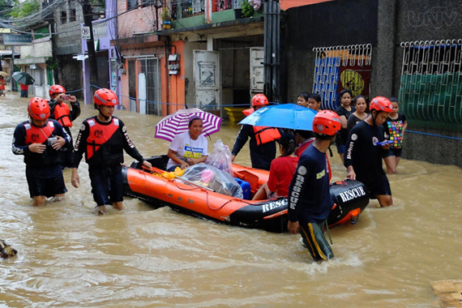1.  2.**

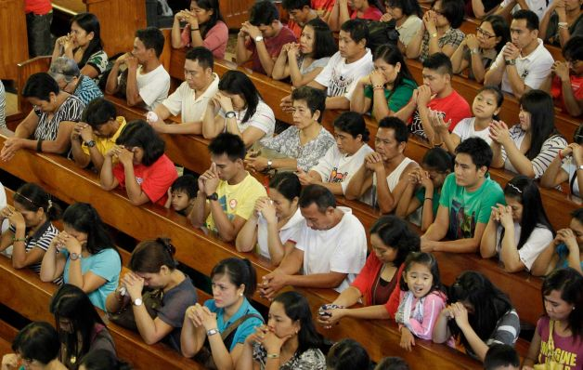

**3.**

1. **ASSIGNMENT**

1. Cite other pictures/visual media that suggest values.

2. Study the Affixes.

Prepared by:

**SUNSHINE D. HABANA**

Student teacher